
P{
ECORAIL®
BIOBASED
RAIL SWITCH PLATE
LUBRICANT
Safe for the Railroad-Safe for the Environment EnvironmentEnvironment
BIOBASED RAILROAD LUBRICANTS
A Railmark Company
PO Box 613 ▪ Henderson, KY 42419 ▪ Tel (812) 454-2350, Sales Direct ▪ www.railmark.com

ECORail® Products by Railmark Track Works
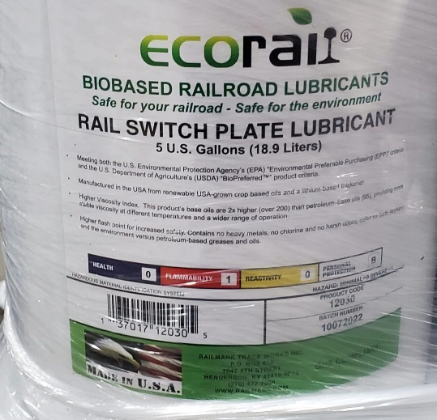

Railmark Track Works presents its ECORail® brand of biobased rail lubricants featuring superior lubricity, resulting in less friction which translates to less heat and less wear. Railmark biobased railroad lubricants and greases include Rail Switch Plate Lubricant and Top-of-Rail Grease, for use in all rail lubricating applications and equipment.
ECORail®’s Rail Switch Plate Lubricant outperforms both water-based, petroleum-based, and synthetic greases, providing superior lubricity between suggested 30-day applications. This product also performs well when used by those wayside lubricators requiring this texture.
Railmark has been offering its ECORail® biobased rail lubricants to railroads and rail users along with Railmark’s customized lubrication maintenance programs since 2012.
- Premium quality biobased switch plate lubricants, exceeding any others on the market with superior lubricity resulting in less friction, less heat and less wear.
- Works in manual application and with all wayside lubricators requiring the liquid texture.
- Meets U.S. Environmental Protection Agency’s (EPA) “Environmental Preferable Purchasing (EPP)” criteria and is a U.S. Department of Agriculture (USDA) “BioPreferred™” product and is “Biobased Labeled”.
- Manufactured in the USA from renewable US-grown crop-based oils and a lithium-based thickener. Supports the US farmer and US small business.
- Higher Viscosity Index. Its base oils are 2x higher (over 200) than petroleum–based oils (95), providing more stable viscosity at different temperatures and a wider range of operation.
- Outperforms many synthetics based on tests and usage and is less expensive.
- Due to their polarity, biobased molecules bond and adhere to metal surfaces better than petroleum-based oils and greases.
- Higher flash point than mineral greases for increased safety.
- Contains no heavy metals, no chlorine, and no harsh odors. Safer for both your workers and the environment versus petroleum-based greases and oils.
PRODUCT STRENGTHS
Request a Quote:
sales@railmark.com
Available in:

- 5-Gallon Plastic Pails (Item #12030)

- 55-Gallon Metal Drums (Item #12031)

- 275-Gallon Plastic Totes (Item #12032)
www.railmark.com
www.ecorail.net

