

ECORAIL®
TOP-OF-RAIL
GREASE
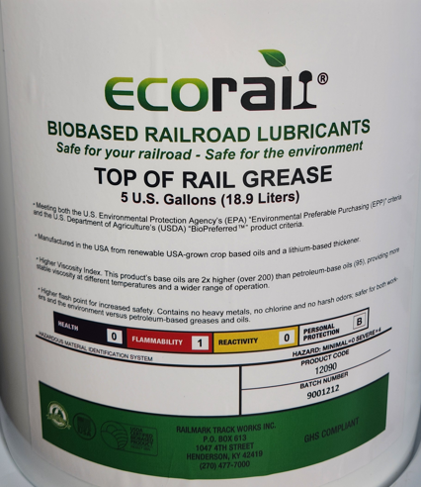

Available in:
- 5-Gallon Plastic Pails
(Item #12090)
- 55-Gallon Metal Drums
(Item #12091)
- 275-Gallon Plastic Totes
(Item #12092)
Request a Quote: sales@railmark.com
www.railmark.com www.ecorail.net





BIOBASED RAILROAD LUBRICANTS

ECORail® Products by Railmark Track Works
ECORail®’s Top-of-Rail Grease is environmentally safe while providing greater performance than water-based or petroleum-based products. ECORail®’s Top-of-Rail Grease has a naturally higher viscosity index creating a more temperature stable product, as well as offering a naturally higher thin film strength.
Petroleum-based Grease

Water-based Lubricant

Railmark TOR Biobased Grease

Due to their polarity, vegetable oil molecules adhere better to metal surfaces than mineral oils, thus requiring fewer chemical additives. The result is that ECORail® Top-of-Rail Grease withstands pressure better and is less likely to thin out at higher temperatures.
Product base | Crop Oils | Water | Petroleum
Container sizes | 5 gal  55 gal  275 gal | 5 gal | 5 gal  55 gal  275 gal
Flammable | No | No | Yes
Odor | None | None | Yes
Freezing point (°C) | -25 | -6 | -25
Viscosity, cP @ 25°C | 900-1000 | 825-1100 | 600-700
Meets EPA’s “EPP” | Yes | No | No
USDA  “BioPreferred” | Yes | No | No
Biobased labeled | Yes | No | No

ECORail®’s Top-of-Rail Grease works in all wayside lubricators for top of rail discharge. ECORail®’s Switch Plate Lubricant works in all “spray-type” wayside lubricators. Both biobased products work with manual or spray applications. Railmark has been offering its ECORail® biobased rail lubricants to railroads and rail users along with Railmark’s customized lubrication maintenance programs since 2012.

PRODUCT STRENGTHS
- Extends the life of rail (railhead).
- Extends the life of equipment (wheel tread).
- Increases fuel efficiency.
- Works in all wayside lubricators and manual applications.
- Reduces harmful effects of lateral forces.
- Decreases derailment potential.
- Reduces noise.
- Increases rail grinding intervals.
- Higher viscosity index. Its base oils are 50% higher (900-1000) than petroleum– based oils (600-700), providing more stable viscosity at different temperatures and a wider range of operation.
- Meets U.S. Environmental Protection Agency’s (EPA) “Environmental Preferable Purchasing (EPP)” criteria and is a U.S. Department of Agriculture (USDA) “BioPreferred™” product and is “Biobased Labeled”.

- It contains no heavy metals, no chlorine, and no harsh odors.
A Railmark Company
PO Box 613 ▪ Henderson, KY 42419 ▪ Tel (812) 454-2350, Sales Direct ▪ www.railmark.com

